|  |
| --- |
| 9 Areas of Project Management |
| Vintage Vogue: ITP Semester 2011 |
| John Agbulos, Norman Taminaya, Cameron Ly, Sang Uk Kim |

Contents

Version Controls 4

Introduction 6

Content summary of the Nine Management Areas 6

Communications 6

Cost 7

Human Resource 7

Procurement 7

Quality 7

Risk 7

Scope 8

Time 8

Project Integration 9

Project integration plan 9

Communications 10

Policy 10

Procedure 10

Directory 10

Communication Matrix 12

Human Resource 13

Policy 13

Procedure 13

HR Planning 14

Roles and Responsibilities 15

Work Allocation: John Agbulos (Project Leader) 16

Work Allocation: Norman Taminaya (Documentation Specialist) 16

Work Allocation: Cameron Ly (Lead Programmer) 17

Work allocation: Sang Uk Kim (Quality manager) 17

Procurement 19

Policy 19

Procedure 19

List of procured items 19

Procurement attainment 20

Quality 21

Policy 21

Procedure 21

Defect Report 21

Component: “Vintage Catalogue Component” 21

Quality measurements 26

Risk 28

Policy 28

Procedure 28

Risk Log 28

Detailed risk assessment: Risk 1(Project not completed by the due date) 31

Detailed risk assessment: Risk 4 (Installing Joomla! and its components to windows server does not work) 31

Scope 33

Policy 33

Procedure 33

Scope statement 33

Change Request: Provide a web environment to demonstrate components 34

Time 36

Policy 36

Procedure 36

Start and end dates 36

Work breakdown structure 37

Milestones 37

Timeline 38

# Version Controls

Communication

|  |  |  |
| --- | --- | --- |
| Version | Description | Date |
| 1.0 | Original Communication document | Aug 19 |
|  |  |  |
|  |  |  |

Human resource

|  |  |  |
| --- | --- | --- |
| Version | Description | Date |
| 1.0 | Original Communication document | Aug 19 |
|  |  |  |
|  |  |  |

Procurement

|  |  |  |
| --- | --- | --- |
| Version | Description | Date |
| 1.0 | Original Procurement Document | Aug 19 |
| 1.1 | Added Joomla! Tutorial Videos | Sept 5 |
| 1.2 | Added XAMPP to the document | Oct 10 |
| 1.3 | Added Windows Server 2008 | Nov 13 |

Quality

|  |  |  |
| --- | --- | --- |
| Version | Description | Date |
| 1.0 | Original quality document | Aug 19 |
| 1.1 | Added defect report | Sept 5 |
| 1.1 | Added detailed defect report: “Vintage Vogue Component” | Nov14 |

Risks

|  |  |  |
| --- | --- | --- |
| Version | Description | Date |
| 1.0 | Original Risk document | Aug 19 |
| 1.1 | Modified risk due to strong adherance to schedule | Sept 5 |
| 1.2 | Added XAMPP to the document | Oct 10 |
| 1.3 | Added windows server 2008 implementation | Nov 13 |
| 1.4 | Added new risk, new technological standard appears, due to new version of Joomla! being released | Nov 16 |

Scope

|  |  |  |
| --- | --- | --- |
| Version | Description | Date |
| 1.0 | Original scope document | Aug 19 |
| 1.1 | Requirement #12, changed from “Install components on web server” to “Provide a web environment to demonstrate components” | Nov 14 |
| 1.2 | Added Change request: Provide a web environment to demonstrate components | Nov 15 |

Time

|  |  |  |
| --- | --- | --- |
| Version | Description | Date |
| 1.0 | Original time document | Aug 19 |
| 1.1 | Changed due date from Nov 14 to Nov 22 | Nov 15 |
|  |  |  |

# Introduction

The nine areas of project management are the key competencies that a project must develop in order to properly organize and manage activities in a project. Namely the nine areas are:

1. Communications: refers to the management of the communication channels which all the stakeholders undertake
2. Cost: refers to the management of the estimated and actual costs of the project budget. Due to the nature of the Vintage Vogue Project being a cost free project, cost was excluded from the document
3. Human Resource: refers to the management of the personnel resources of the project
4. Procurement: refers to the management of the required hardware, software, facilities and services required to complete the project
5. Project Integration: refers to the process and procedure that coordinate the eight other areas to work effectively together
6. Quality: refers to the management of the specified standards which ensure quality of a project
7. Risks: refers to identification, analysis, and classification of risks to the project and the development of contingency plans and mitigation strategies to reduce the impact and negative risks to the project
8. Scope: refers to the management of the deliverable items to be delivered by the project, including the tasks and activities to be conducted to complete the deliverables
9. Time: refers to the management of the scheduled activities undertaken to complete the project

# Content summary of the Nine Management Areas

Each of the areas of management have two components in common: policy and procedures.

The policy consists of a widespread application and is expressed in broad terms. It outlines the method in which to conduct the particular management area.

Procedure on the other hand, is a narrow application and describes a detailed, specific method of describing the management process.

More specifically each management area contains more detail on the subject.

## Communications

Communications contains:

* Directory: contains all the contact details of the stakeholders, including project members, advisors and stakeholders
* Communication Matrix: shows the communication channels between group members, client and advisors

## Cost

Due to the nature of the project being a cost free project, the group decided not to conduct a cost management document. The cost for the project is time.

## Human Resource

Human Resource contains:

* HR Planning: Shows which group classification each stakeholder belong to. Also briefly outlines formal communication hierarchy between stakeholder groups.
* Roles and Responsibilities: Shows the major roles and responsibilities of each of the group members, also shows what is to be expected from the client and advisors. It also serves as a brief description of each of the stakeholders of the project
* Work allocation: Shows the schedule of the major tasks for each individual in the project. The work allocation is not 100% accurate as there are some minor work not worth noting in the document

## Procurement

Procurement contains:

* List of procured items: Describes the justification for procuring items for the project. Also shows the time they were procured.
* Procurement attainment: Describes the method and cost of procuring the items in the list

## Quality

Quality contains:

* Defect report: A list of the implemented and defects within the Vintage Vogue project
* Testing report: A testing report which shows the testing which has been executed by the Vintage Vogue team

## Risk

Risk contains:

* Risk log: A log of all the risks which threaten the project, along with its likelihood of occurance, impact of the project if it were to occur, mitigation action and current status.
* Detailed risk assessment: All outstanding risks throughout the project are analysed in detail. The detailed risk assessment describes, more specifically, the issue, its proposed solution and/or its mitigation strategy.

## Scope

Scope contains:

* Scope statement: At the start of the project all the requirements, boundaries, tolerances, assumptions and milestones are agreed upon by both client and team. As a whole all these are the scope of the project
* Change requests: If any change is to be made on the scope of the project a change request must be completed and documented, in order for both team and client to agree on any change

## Time

* Start and end dates: Describes when the Vintage Vogue project will begin and when it will end
* Work breakdown structure: Shows the estimate of the work to be completed throughout the project.
* Milestones: Shows the major deliverables to be completed during the project lifetime
* Timeline: A graphical representation of the iteration phases of the project

# Project Integration

Project integration is the combination of all the 8 areas of management to correspond with each other and the project. This document itself is classified under project integration, however there were more specific processes involved in handling integration of the areas of management.

The team devised a chart which shows the rippling change to one area of the project. The diagram below shows such change management and how to integrate it to the other areas of management.

## Project integration plan

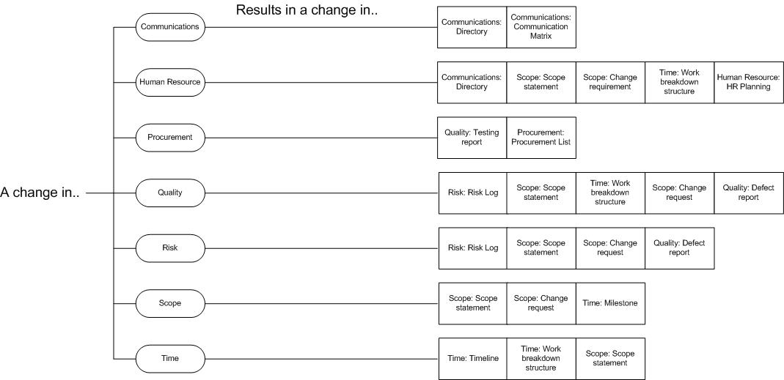

# Communications

## Policy

|  |  |
| --- | --- |
|  | Policy |
| 1 | Identification of communication channels |
| 2 | Document the communication channel into the communications management document |
| 3 | Constantly monitor the communication channels to keep up to date |

## Procedure

|  |  |
| --- | --- |
|  | Procedure step |
| 1 | If a new communication channel arises then the project leader is notified |
| 2 | The new communication channel is added into this document |

## Directory

Team Directory

Name: John Agbulos

Position: Project leader

Mobile Phone: 0430 441 533

Telephone:

Email: u3030429@uni.canberra.edu.au

Student number: u3030429

Name: Norman Taminaya

Position: Documentation specialist

Mobile Phone: 0411 313 843

Telephone: 6259 3195

Email: norman_tamin@hotmail.com

Student number: u3037276

Name: Cameron Ly

Position: Lead programmer

Mobile phone: 0430 393 382

Telephone: 6242 4271

Email: u3036875@uni.canberra.edu.au

Student number: [u3036875](mailto:u3036875@uni.canberra.edu.au)

Name: Sang Uk Kim

Position: Quality Assurance Manager

Mobile phone: 0434 235 779

Telephone:

Email: [anonimos2001@hotmail.com](mailto:anonimos2001@hotmail.com)

Student number: u3044378

Stakeholder contacts

Name: Rene Sutherland

Position: Project Client

Mobile: 0408 319 796

Phone: 6234 7348

Email: [rene.sutherland@svdp-cg.org.au](mailto:rene.sutherland@svdp-cg.org.au)

Name: Lauren Estabillo

Position: Advisor, Future user

Mobile: 0427 541 841

Telephone: 6175 6407

Email: [lauren.estabillo@anclerd.com.au](mailto:lauren.estabillo@anclerd.com.au)

Name: Dale Kleeman

Position: Advisor, Tutor

Phone: **6201 2427**

Email: [Dale.Kleeman@canberra.edu.au](mailto:Dale.Kleeman@canberra.edu.au)

Name: Charles Palmer

Position: Unit Convenor, Advisor

Phone: **6201 2432**  
Email: Charles.Palmer@canberra.edu.au

## Communication Matrix

|  |  |  |  |  |  |  |
| --- | --- | --- | --- | --- | --- | --- |
|  | Communication type | Objective of communication | Medium | Frequency | Audience | Deliverable |
| 1 | Status reports | Review status of the project with the team | Document | Monthly | Project members, Client | Status report |
| 2 | Project team meeting | Conducting project work, including programming, documentation, presentation preparation, etc | Face to face | Approximately 2-3 times a week, ranging from 3-6 hours each meeting | Project members | Agenda |
| 3 | Email | Emails can be sent between group members or to the client. Serves as a method of communication | Informal document | On need basis | Project members, client | Email |
| 4 | Presentation in ITP tutorial | Once in a while a presentation is needed to be presented to the ITP tutorial. It serves as a method of updating advisors and colleagues of the progress of the proejct | Face to face | Approximately once a fortnight | Project members, advisor,  ITP colleagues | Agenda |
| 5 | Telephone | Sometimes a group member has to contact another member, so mobile phones are used | Speech | On need basis | Project members | Agenda |
| 6 | Meeting with client | A face to face meeting with the client has been scheduled to occur 4-5 times during the project lifetime. The meetings server to show the client the progress of the project and if they agree/disagree with implemented features | Face to face | Once every 3 weeks | Project members, client | Agenda, software build |

# Human Resource

## Policy

|  |  |
| --- | --- |
|  | Policy |
| 1 | Identify all human resources involved in the project |
| 2 | Ensuring that resource levelling is followed to avoid over-allocation of resources |
| 2 | Any new people/person is to be added into the roles and responsibilities |
| 3 | Any changes in contact details will change the communications document and the human resource document |

## Procedure

|  |  |
| --- | --- |
|  | Procedure |
| 1 | At the beginning of the project all the human resources are listed in this document |
| 2 | They will be listed in the communications document and this document. The project structure will be changed |
| 3 | Work allocation will be estimated for the new member(if part of the team), if an external resource then modify the roles and responsibilities |

## HR Planning

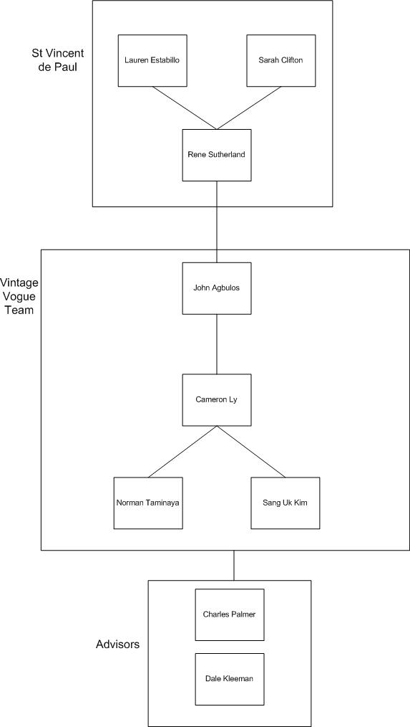

Fig 1.1 Overall project structure

Figure 1.1 Shows a general view of all the stakeholders involved in the project. It shows all the human resources involved in the Vintage Vogue project team. In the Vintage Vogue Team box it shows the approval channels between all the project members. Whilst all the team members still communicate regularly, the hierarchy only shows the order of change process(which is covered in depth in the Change management document).

## Roles and Responsibilities

John Agbulos: Project leader

The main role of the project leader is to organize and delegate the project activities. Despite the title the project leader will still perform programming and documentation. The project leader also represents the team in communication between the client and the team.

Sang Uk Kim: Quality assurance manager

The main role of the QAM is to ensure quality and consistency in all the deliverables of the team, including software and documentation deliverables. Testing is also a role which the QAM undertakes further strengthening the quality of the software deliverable.

Cameron Ly: Lead programmer

The main role of the lead programmer is to organize and oversee the programming aspect of the project as a whole. Testing is also a part of the lead programmers responsibilities.

Norman Taminaya: Documentation specialist

The main role of the documentation specialist is to create and maintain all the documentation related to the project. Includes logging the changes to documents, most changes pass through the documentation specialist which has to be approved.

Rene Sutherland: Project sponsor

The sponsor of the Vintage Vogue project. Responsible for the vision of the project which the project team manifests into a software solution.

Lauren Estabillo and Sarah Clifton: Advisor

An advisor to Rene Sutherland, also part of the Vintage Vogue team in the St Vincent de Paul side.

Dale Kleeman: Tutor/Advisor

Dale is the assigned tutor for the Vintage Vogue team's tutorial. He acts as an advisor and provides advice to the group

## Work Allocation: John Agbulos (Project Leader)

|  |  |
| --- | --- |
| Schedule | Task/Responsibility |
| Week 1 | Develop the project charter  Requirements/Procurement research and gathering  Create pre project document |
| Week 2 | Detailed requirement analysis  Sign-off project charter  Conduct risk analysis  Conduct system design |
| Week 3 | Continue work from week 2  Begin documentation of 9 areas of management |
| Week 4 | Begin first iteration of development  4+1 SAD document |
| Week 5 | Programming and testing first iteration |
| Week 6 | Finalize first iteration  Re-assess 9 areas of management following client meeting |
| Week 7 | Re-evaluate risk, design and requirements |
| Week 8 | Help in programming second iteration |
| Week 9 | Finalize second iteration  Re-evaluate risk, design and requirements |
| Week 10 | Re-assess 9 areas of management following client meeting  Begin third iteration |
| Week 11 | Development of third iteration  Conduct unit/system testing |
| Week 12 | Development of third iteration  Conduct unit/system testing |
| Week 13 | Development of third iteration  Conduct unit/system testing  Re-assessing the entire document |
| Week 14 | Project closure |

## Work Allocation: Norman Taminaya (Documentation Specialist)

|  |  |
| --- | --- |
| Schedule | Task/Responsibility |
| Week 1 | Develop the project charter  Requirements/Procurement research and gathering |
| Week 2 | Detailed requirement analysis  Sign-off project charter  Conduct risk analysis  Conduct system design |
| Week 3 | Continue work from week 2  Begin documentation of 9 areas of management  Create first status report |
| Week 4 | Begin first iteration of development  4+1 SAD document |
| Week 5 | Programming and testing first iteration |
| Week 6 | Finalize first iteration  Re-assess 9 areas of management following client meeting |
| Week 7 | Re-evaluate risk, design and requirements  Document any changes made to the project |
| Week 8 | Create second status report  Help in programming second iteration |
| Week 9 | Finalize second iteration  Re-evaluate risk, design and requirements |
| Week 10 | Re-assess 9 areas of management following client meeting  Begin third iteration |
| Week 11 | Create third status report  Development of third iteration  Conduct unit/system testing |
| Week 12 | Development of third iteration  Conduct unit/system testing |
| Week 13 | Development of third iteration  Conduct unit/system testing  Re-assessing the entire documentation |
| Week 14 | Project closure |

## Work Allocation: Cameron Ly (Lead Programmer)

|  |  |
| --- | --- |
| Schedule | Task/Responsibility |
| Week 1 | Develop the project charter  Requirements/Procurement research and gathering |
| Week 2 | Detailed requirement analysis  Sign-off project charter  Conduct risk analysis  Conduct system design |
| Week 3 | Continue work from week 2  Research software development in Joomla! |
| Week 4 | Begin first iteration of development  4+1 SAD document |
| Week 5 | Programming and testing of first iteration |
| Week 6 | Finalize first iteration |
| Week 7 | Re-evaluate software implementation, design and scope  Begin second iteration |
| Week 8 | Continue programming second iteration  Unit/System testing of second iteration |
| Week 9 | Finalize second iteration |
| Week 10 | Re-evaluate software implementation, design and scope  Begin third iteration |
| Week 11 | Development of third iteration  Conduct unit/system testing |
| Week 12 | Development of third iteration  Conduct unit/system testing |
| Week 13 | Development of third iteration  Conduct unit/system testing |
| Week 14 | Project closure |

## Work allocation: Sang Uk Kim (Quality manager)

|  |  |
| --- | --- |
| Schedule | Task/Responsibility |
| Week 1 | Develop the project charter  Requirements/Procurement research and gathering |
| Week 2 | Detailed requirement analysis  Sign-off project charter  Conduct risk analysis  Conduct system design |
| Week 3 | Continue work from week 2  Research software development in Joomla! |
| Week 4 | Begin first iteration of development  4+1 SAD document |
| Week 5 | Programming and testing of first iteration  Ensure that 4+1 SAD document is consistent and of high quality |
| Week 6 | Finalize first iteration |
| Week 7 | Re-evaluate software implementation, design and scope  Begin second iteration |
| Week 8 | Continue programming second iteration  Unit/System testing of second iteration |
| Week 9 | Finalize second iteration |
| Week 10 | Re-evaluate software implementation, design and scope  Begin third iteration |
| Week 11 | Development of third iteration  Conduct unit/system testing |
| Week 12 | Development of third iteration  Conduct unit/system testing |
| Week 13 | Development of third iteration  Conduct unit/system testing |
| Week 14 | Project closure |

# Procurement

## Policy

|  |  |
| --- | --- |
|  | Policy |
| 1 | Identify initial procurement |
| 2 | Any new procured items will be documented |
| 3 | Any changes will require a change in the procurement documentation |

## Procedure

|  |  |
| --- | --- |
|  | Procedure |
| 1 | At the beginning of the project all the estimated procured items are listed in this document |
| 2 | Any changes to said procurements will be altered |
| 3 | Project leader will view the new procurements and add to the document. The list of procured items, procurement attainment and the procurement log will be updated. |

## List of procured items

|  |  |  |
| --- | --- | --- |
| Item/Service | Justification | Procured on |
| Web host (http://burbank.directrouter.com/~vogue/) | A web host is needed to make the website available on the internet. It will also facilitate a host for Joomla, mySQL, phpMyAdmin, filezilla and its components. | Aug 22 Week 2 |
| Joomla! version 1.7 | Joomla! is a Content Management System(CMS) which was elected as the platform of choice by the client. Joomla! provides a front and back end which provides good Information Security. | Aug 22  Week 2 |
| Joomla! Tutorial Videos(www.lynda.com) | Lynda.com provides a tutorial for Joomla! development. The video was needed due to the team’s lack of expertise and experience in Joomla! development | Sept 5  Week 4 |
| Community Builder Profiler(Joomla Component) | The component handles profile management for the front and back end of the system. The component is freeware and available for download in the Joomla! website | Sept 5  Week 4 |
| Udja Commenting(Joomla Component) | The component handles commenting on the Joomla! website. The component is freeware and available for download in the Joomla! website | Week 5  Week 4 |
| XAMPP (includes mySQL, phpMyAdmin, filezilla) | XAMPP is a web server which can be installed on non-server PC’s. It includes mySQL, phpMyAdmin and filezilla services. It allows the team to develop and test code in their computers. | Oct 10  Week 9 |
| PayPal Sandbox | PayPal sandbox is a service provided by PayPal which is a testing environment for purchases done via PayPal. It allows a programmer to develop PayPal transactions without the purchase | Sept 5  Week 4 |
| Windows Server 2008 | During the final stage of the project, the component the group created would not work on the web server. The group used windows server 2008 as an alternative method to web hosting to test if the problem was in the server or the code | Nov 13  Week 14 |

## Procurement attainment

|  |  |  |
| --- | --- | --- |
| Item/Service | Method of attainment | Cost |
| Web host (http://burbank.directrouter.com/~vogue/) | The web host was provided by our client(Rene Sutherland) free of charge. The web host was also chosen by the client | $0 |
| Joomla! version 1.7 | Joomla! is a free ware CMS. It is attainable on the website joomla.org | $0 |
| Joomla! Tutorial Videos(www.lynda.com) | A subscription is needed to view all the videos on Lynda.com. Credit card payment was used to pay for the subscription | $37 |
| Community Builder Profiler(Joomla Component) | The component was available on Joomla! components on their website. | $0 |
| Udja Commenting(Joomla Component) | The component was available on Joomla! components on their website | $0 |
| XAMPP (includes mySQL, phpMyAdmin, filezilla) | XAMPP is available to download from their website:  http://www.apachefriends.org/en/xampp.html | $0 |
| PayPal Sandbox | Paypal sandbox is available through the url:  https://developer.paypal.com/ | $0 |
| Windows Server 2008 | Cameron Ly already had a copy of windows server 2008 | $0 |

# Quality

## Policy

|  |  |
| --- | --- |
|  | Policy |
| 1 | The initial quality report is created after the completion of the first iteration |
| 2 | Monitor changes to defect throughout the project, if a defect is severe create a detailed defect report |
| 3 | At the completion of the project create a finalized outstanding defect report |

## Procedure

|  |  |
| --- | --- |
|  | Procedure |
| 1 | Create defect report |
| 2 | Create testing report |
| 3 | At the end of each build modify the defect and testing report |

## Defect Report

|  |  |  |  |
| --- | --- | --- | --- |
| System Requirements | Status | Severity | Cause of defect |
| Backup feature | Working |  |  |
| User profiles | Working |  |  |
| Increase and decrease stock | Working |  |  |
| Publish/unpublish the unsold/sold stock | Working |  |  |
| Create new stock | Working |  |  |
| Edit stock details | Working |  |  |
| Disable profile | Working |  |  |
| Create new profile(register) | Working |  |  |
| Editing profile | Working |  |  |
| Delete profile | Working |  |  |
| Call to action button | Not implemented | Minor | Not implemented yet |
| Paypal sandbox access | Working |  |  |
| Installing components on web host | Defect | Major | Problems with web host and Joomla! compatibility |

## Component: “Vintage Catalogue Component”

Defect type:

The component itself is functional in that the catalogue is able to add, delete and edit the stock that is inside the MySQL database. This function is accessible by logging through the administration side of the website (Logging through the backend is shown in the instruction manual). To add new stock the administrator will need to enter the details of the product For example he/she has to enter the name, the product price, product size, category, colour, any notes added by the administrator and lastly the image of the product. The images are going to be provided by the staff of St. Vincent de Paul Society, the component ONLY allows for images to be uploaded.

The environment of the component was run on both the local host and on the web server. It is running perfectly if it is on the local host and does what we had intended it to do from the project charter which is adding, editing and deleting the stock. The problem arises when it is put web server in that it doesn’t allow the component to be viewed in the administration or in the front end of the website. Figures 1-3 describes the component working in the local host.

Figure 1: Adding a new product in the local host

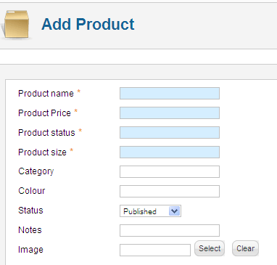

Figure 2: Editing the products

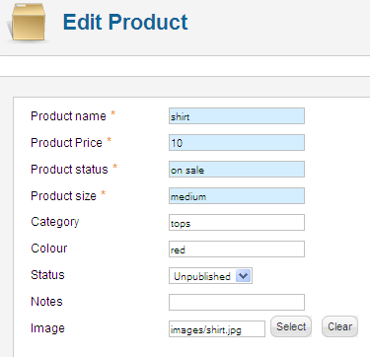

Figure 3: Deleting the products



The component is at a stage where it is functional in the local host but it does not run properly in the web server. We believe this is due to the change that Joomla implemented that shifts all the extensions which includes modules, components and plug-ins under the General Public License(GPL) to the Joomla Extension Directory (JED). The reason of the change is so that the Joomla community, which includes all the users and developers of Joomla, have easier access to the extensions that have been created under GPL standards which is also used to monitor the extensions that is being created by developers. The change was implemented on the 31st of March 2009, commercial licenses or non-GPL extensions are not listed in the Joomla Extension Directory, this then leads the problems that we have encountered in our attempt to install and make it work online in the web server.

These problems were:

* We indicated in the project charter that all intellectual property will *remain* with St Vincent de Paul Society Canberra Goulburn Central Council which then leads to the following issue of placing the component that the team created. If the Vintage Catalogue is shifted to the Joomla Extension Directory we believe that it will violate the contract of the project charter, because we never technically owned the component to start with.
* To be able for the component to be able to function normally in the web server we believe that it is mandatory for the code to be encrypted to comply with the JED which would not be possible because we won’t be eligible for the GPL license for our case.

The result of the component being installed in the web server is shown

Figure 4: administration side

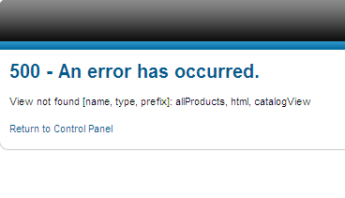

Figure 5: this is the view of the component in the front end

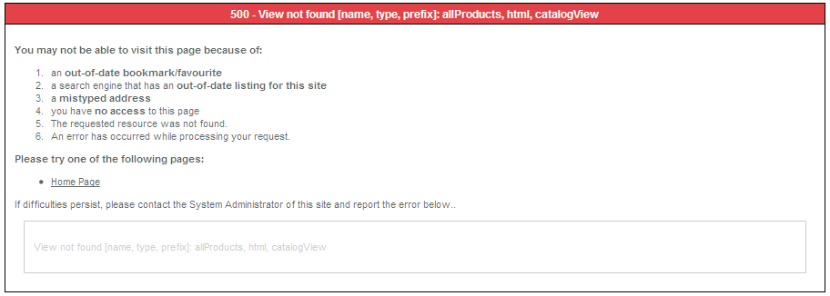

## Quality measurements

|  |  |  |  |
| --- | --- | --- | --- |
| Quality type | Rating out of 5 | Reason | Fix |
| Features | 4 | * 95% of the agreed functionality have been completed * Features where completed by the due date | * Upload the component on the web server * Complete the remaining 5% of the functionality |
| Performance | 2 | * Features are implemented, unfortunately migrating into web host proved to be out of scope and lacking in time | * Due to the component installation not working on the web host, performance wasn’t properly tested * A suggestion for the next iteration of the project is to complete the GNU GPL required to run the system on a web host |
| Reliability | 2 | * The reason for the low mark is due to the component being run on local host so some features cannot be fully tested * However some marks are given because the testing report has yielded positive results and confirmation of functionality * A backup feature is also available through cPanel of the web host providing a reliable method of creating a backup of the server | * Due to the component installation not working on the web host, reliability wasn’t properly tested * In the end of the next iteration stress testing and data integration testing must be conducted to assure reliability quality |
| Maintainability | 4 | * Joomla components are individual components, therefore maintenance can be isolated to one function | * A backup feature is available in the cPanel, if maintenance is needed a backup of the current state can be initiated |
| Portability | 4 | * Joomla CMS and its components are easily installed into many forms of web hosts and local hosts * Joomla is not platform specific * Platform Support for php and mysql | * A rating was lost due to the porting to the web host being unsuccessful |
| Efficiency | 0 | * Efficiency could not be tested due to Joomla handling processes * It is hard to gauge the performance of the web host | * Stress testing can determine the efficiency of the overall system * A comparison is needed to test efficiency of the project. Specifically another method such as a non CMS version of the website must be made to compare the efficiency |
| Extensibility | 5 | * Joomla has installation for components which isolate functionality * Proper documentation has been provided for the next iteration of developers to complete and/or extend the web site | * Joomla has many open source extensions and components. For the next build if another function is required then the developers can download the needed component/extension |
| Total = 21/35 | | | |

# Risk

## Policy

|  |  |
| --- | --- |
|  | Policy |
| 1 | Identification of risks ensuring that it is done in the early stages of the project |
| 2 | Managing the risks that have risen in a way that it doesn't cripple the project |
| 3 | Mitigating the risks appropriately in order to curb it's effect on the project |
| 4 | Constantly monitoring risks throughout the lifetime of the project to avoid negative risks and eventually producing a quality system |

## Procedure

|  |  |  |
| --- | --- | --- |
|  | Procedure steps | Responsibility |
| 1 | In the next group meeting the new risk will be informally discussed and solutions will be brain stormed | Project leader |
| 2 | If a solution can be executed easily then the risk log will be updated. If the risk requires more work then the issue will be put into the risk log and a detailed risk assessment will be conducted | Project leader |
| 3 | Update the risk log to monitor that the risk has occured | Project leader |
| 4 | Execute mitigation strategy | Project leader |
| 5 | Update risk log | Project leader |

## Risk Log

|  |  |  |  |  |  |
| --- | --- | --- | --- | --- | --- |
| No. | Description | Likelihood | Impact | Mitigation actions | Current status |
| 1 | Project not completed by the due date | Medium | Medium | An acceptable compromise will be made to present the final solution in local host or attempt to host the website on a different server | The catalogue component has an unknown error in the webhost, the group is investigating |
| 2 | Group member leaves project or has to take temporary leave | Low | High | If a member is to leave the group unexpectedly, then the scope and time allocation of the project will be changed to account for the loss of resources | No group member has left. |
| 3 | Client changes key deliverables and/or demands infeasible changes | Low | High | The group will review the new deliverable and assess if it is possible to make the change | No unreasonable demands have risen |
| 4 | Installing Joomla! and its components to windows server does not work | High | Medium | The final product will be presented and handed in through local host (XAMPP) | Not resolved |
| 5 | Client does not respond quickly to group communication attempts | Medium | Low | The group will attempt to contact the client early in order to account for a late reply | No current issues |
| 6 | Documentation is not completed by the due date | Low | Medium | The group has been working consistently throughout the year to maintain the documentation | All documentation is completed |
| 7 | The web host, for any reason, ceases to operate | Low | High | There is no effective mitigation since the web host is external and beyond the group's immediate control | Web host still operations, however there are issues with installing the group's components onto it |
| 8 | The client is not unsatisfied with final product | Medium | Low | Due to a high communication between client and the team, all changes made have been presented to the client. The client is aware of the changes and decisions the group has been making | As of the last meeting the client is happy with our progress |
| 9 | The final solution's security contains serious vulnerabilities | Medium | Low | Due to the client stating that the final product will not be a live solution the impact is not that great. If the client wishes to develop it further in order to be a live website then the team will need to return to do another iteration of the project to specifically fix the security vulnerabilities | There are no current vulnerabilities due to the component not being able to be installed on the web host. Also due to the payment system being handled by PayPal the payment system is assumed safe |
| 10 | New technological standard appears, more specifically a new version of Joomla! appears | Medium | Low | There is no mitigating the change since it is an external influence | When the project began the group used 1.7.0 and during the development Joomla! released 3 minor builds. Currently it is up to 1.7.3 |
| 11 | Legal/intellectual property issues | Medium | High | A change has to be made if a component is considered illegal or plagiarism has been found in one of the group’s components | No legal/intellectual issues have risen |

## Detailed risk assessment: Risk 1(Project not completed by the due date)

Date: 13/11/2011

Most of the project deliverables have been completed at the end of week 13(11th November), however a new problem has risen where the Joomla! components are experiencing problems when installed on the webhost.

The group has brainstormed and decided on a couple of solutions to fix the problem. The first solution is to ask our client if there are any access controls inside the server which the group does not know about. Secondly, while waiting for the response the group will attempt to upload Joomla! and its components into a windows server 2008 environment, by installing components on the windows server 2008 the group can detect if the problem is indeed with the webhost, an issue with the current version of Joomla! or a problem with the code.  
  
The group suspects that the code is not the problem, because when ran on an XAMPP environment it works every time. So as of this writing we suspect it is due to the webhost.

|  |  |
| --- | --- |
| Mitigation strategy | Result |
| Email Rene Sutherland to investigate the problem with the webhost | N/A |
| Install Joomla! into windows server | N/A |
| Review the code to find problems with installation | In the XAMPP environment the installation works every time. The code doesn't appear to be the problem |
|  |  |

Current Status: Closed

Solution: The group discussed with the client of possibly completing the project in a local host environment. An agreement was met and XAMPP was used to host the local host. The project can be closed appropriately.

## Detailed risk assessment: Risk 4 (Installing Joomla! and its components to windows server does not work)

Date: 13/11/2011

An alternative to the web host is to host our own server using windows server 2008. The alternative strategy is to test where specifically the errors of the components reside. If our speculation is correct and the problem is with the original web host then there is no mitigation to fix the problem and an alternative method must be taken

|  |  |
| --- | --- |
| Mitigation strategy | Result |
| If the windows server solution works then the final solution will include windows server 2008 | Windows Server 2008 solution did not work |
| If the solution does not work then the final solution will be done in a local host | Windows Server 2008 solution did not work |

Current status: Closed

Result: The solution did not work. The project is to be finalized in XAMPP local host environment.

# Scope

## Policy

|  |  |
| --- | --- |
|  | Policy |
| 1 | Identify the scope from the final project charter |
| 2 | At the end of each iteration re-evaluate the scope in comparison with schedule |
| 3 | If a new scope is requested by the client, check with schedule, resources and feasibility |
| 4 | If a new scope is requested by the group, check with schedule, resources, feasibility and client |
| 5 | At the end of the project create a list of which scope requirements was met |

## Procedure

|  |  |
| --- | --- |
|  | Procedure |
| 1 | Create initial scope document based off project charter |
| 2 | For every iteration update the scope document with relevant scope changes |
| 3 | Notify documentation specialist for a change in scope |
| 4 | Documentation specialist contacts client and project leader of project change |
| 5 | If scope change is accepted, update scope document and update log |
| 6 | At the end of the project create defect report with detailed defect descriptions of outstanding defects |
| 7 | Notify defects to client |

## Scope statement

|  |  |
| --- | --- |
|  | Requirements |
| 1 | Backup feature |
| 2 | User profiles |
| 3 | Increase/decrease stock |
| 4 | Publish/unpublish sold/unsold stock |
| 5 | Create new stock |
| 6 | Edit stock details |
| 7 | Disable profile |
| 8 | Create new profile(Register) |
| 9 | Editing profile |
| 10 | Call to action button |
| 11 | Paypal sandbox access |
| 12 | Provide a platform in which to demonstrate the web site |

|  |  |
| --- | --- |
|  | Boundaries |
| 1 | All payments is handled by paypal |
| 2 | No connectivity with web cameras |
| 3 | Web security is handled by Joomla! CMS and no further development will be made by the team |
| 4 | Four members are maintained throughout the entire project |
| 5 | Unreasonable changes to project scope may alter the development quality and schedule of the final product |
| 6 | The project is to be given to the client no later than 25th November |
|  |  |

|  |  |
| --- | --- |
|  | Tolerances |
| 1 | 40% of the features must be presented in the prototype presentation. 90% - 100% of the features must be completed in the final presentation |
| 2 | Final build must have 70% - 100% user acceptance |
| 3 | Average work per week may vary between 18 – 25 hours per week, depending on the phase of the project |
| 4 | Final hand-over tolerance is 1 week, either 1 week before or after the deadline |
| 5 | Another member may be added during the first 2 weeks of the project |
|  |  |
|  |  |

|  |  |
| --- | --- |
|  | Assumptions |
| 1 | Joomla! can be downloaded for free from [www.joomla.org](http://www.joomla.org) |
| 2 | The server for the project is offered by Yellow Brick Road Marketing via Rene Sutherland. |
| 3 | The hardware facility for security is supported by the web host company, On the software side, joomla’s security functionality is used to protect the site |
| 4 | Each member will work on the Vintage Vogue project on average 21 hours a week |
|  |  |
|  |  |
|  |  |

|  |  |
| --- | --- |
|  | Milestones |
| 1 | First iteration – Sept 19 |
| 2 | Second iteration – Oct 10 |
| 3 | Third iteration – Oct 24 |
| 4 | Final delivery of project – Nov 22 |

## Change Request: Provide a web environment to demonstrate components

Originally the project was to be uploaded on the web server. However due to GNU GPL restrictions which was not accounted for by the group. The change was notified to the client on the 15th November via the email seen below.

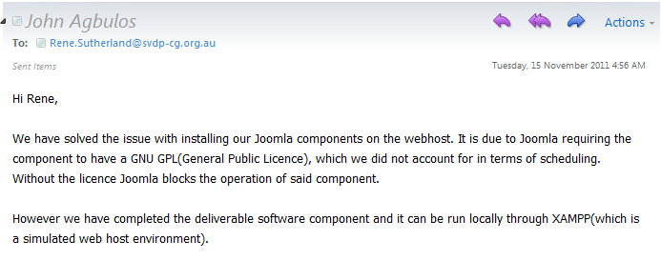

The whole team has agreed for the change. For more information refer to the detail defect report.

# Time

## Policy

|  |  |
| --- | --- |
|  | Policy |
| 1 | Identify time restraints before the creation of the project charter |
| 2 | If there is a time change request notify the client |
| 3 | If time is to change refer to the time document and change appropriately. |
| 4 | Monitor any changes to time and scheduling |
|  |  |

## Procedure

|  |  |
| --- | --- |
|  | Procedure |
| 1 | Create timeline during the project charter creation |
| 2 | Create work breakdown structure after the project charter has been signed off |
| 3 | Monitor any changes, if a change is to be made create a change request and modify the timeline and work breakdown structure accordingly |

## Start and end dates

The project is will begin on the 19th August (Week 1) which is the first week of Semester 2 2011.

The project end date has three different dates providing different deliverables. The first end date is completion of the documentation and any software backups which is on the 19th November, this serves as an internal deadline, allowing group members to feel comfortable with project closure. The second is the final presentation, which shows the project as a whole, to be presented on 21st November. Finally there is the presentation to the client is on the 22nd November 10am.

## Work breakdown structure

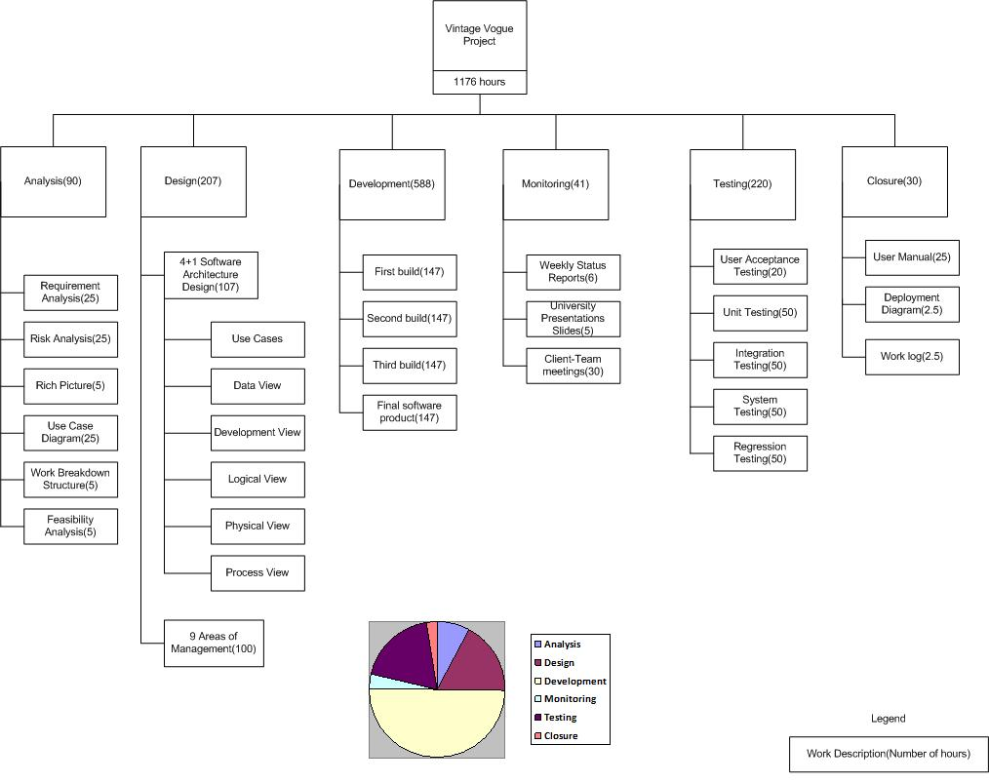

The work breakdown structure demonstrates an approximation of the work to be conducted throughout the semester. Each of the main activities(analysis, design, development, monitoring, testing and closure) consists of analysing, creating and maintaining.

Due to the group’s software development method being Extreme programming, a lot of time was allocated to the development phase. Also testing is to be conducted during and at the end of an iteration build.

## Milestones

|  |  |  |  |
| --- | --- | --- | --- |
| Event or Deliverable | Classification | Target Date | Description |
| Preliminary Period. Search for possible projects | Preliminary period | Jul 7 – Aug 14 | The team will search for project prospects |
| Project Brief/Charter | Design and analysis | Aug 19  Week 1 | Document which outlines the specifics of the project. Face to face contact between team and client is highly advisable |
| Requirement analysis, system design, risk assessment | Design and analysis | Aug 22  Week 2 | Detailed requirements analysis to be undertaken which results in the design of the system |
| First iteration of programming begins | Development | Sept 5  Week 4 | First build of the cycle is developed |
| First prototype developed, unit/system testing | Development | Sept 19  Week 6 | The first build which is shown to the client |
| User acceptance testing | Development | Sept 20  Week 6 | A first glance of the software for the client which they may give feedback on |
| Re-evaluation of risk, design and requirements, second iteration of programming begins | Development/ Design and analysis | Sept 26  Week 7 | According to the user acceptance feedback the team may alter its design, risk and requirements. The second cycle of programming begins |
| Prototype/alpha release completed, unit/system testing | Development | Oct 10  Week 9 | A second cycle in the release sees a much more detailed and complete program |
| User Acceptance Testing | Development | Oct 11  Week 9 | A second user acceptance testing |
| Re-evaluation of risk, design and requirements, third iteration begins | Development/ design and analysis | Oct 17  Week 10 | The third “beta” phase of the programming begins |
| Final user acceptance testing | Development | Oct 24  Week 11 | Beta build demonstrated to client |
| Re-evaluation of risk, design and requirements. Final build begins, thorough unit/system testing | Development/ Design and analysis | Oct 25  Week 11 | The release cycle is undertaken |
| Final presentation to client and project closure | Project closure | Nov 22  Week 14 | Final delivery of project to client |

## Timeline

